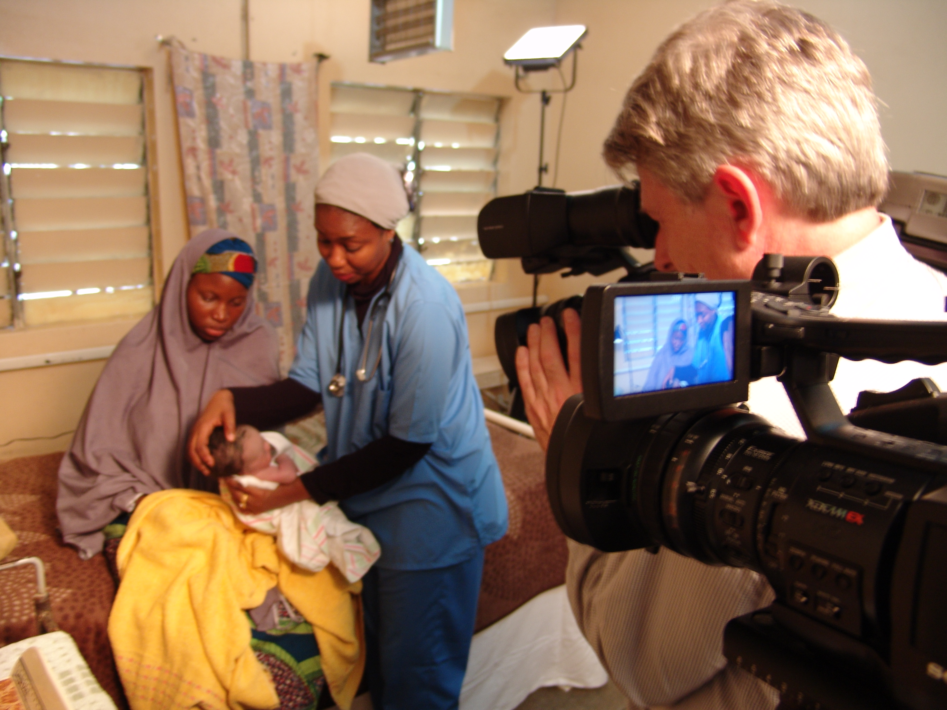

Global Health Media Project is a non-profit start-up dedicated to producing high-quality training films that help health workers save lives in poor countries. We disseminate our videos over the web for health workers to use in training or on mobile devices right at the point of care.

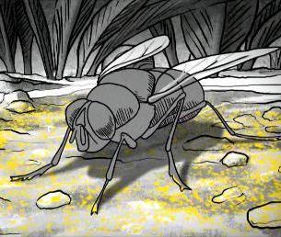

EXCITING internship opportunity

Intern sought to build our social media presence and promote and increase the use of our videos among organizations working in the developing world.

The intern will work closely with the GHMP team to learn our mission and messaging and help use it in email and social media to get our work out to the frontline health workers who need it.

Qualifications:
- A firm grasp of social media platforms
- Excellent writing skills
- Creativity, willingness to experiment with new and alternative ways to leverage social media activities
- Self-starter: able to work independently and to develop a strategy and plans for increasing GHMP's visibility and reach
- Ability to commit to a period of at least 6 months

Stipend will be offered based on productivity as measured by increased social media and website traffic.

This internship is a rare opportunity to contribute in an early and fast moving sector, learn from experienced professionals, and develop relationships with some of the biggest organizations and players in the non-profit Global Health, technology, and mobile sectors.

Interested candidates should forward their CV with a brief cover letter to Deb Van Dyke, dvandyke@madriver.com

